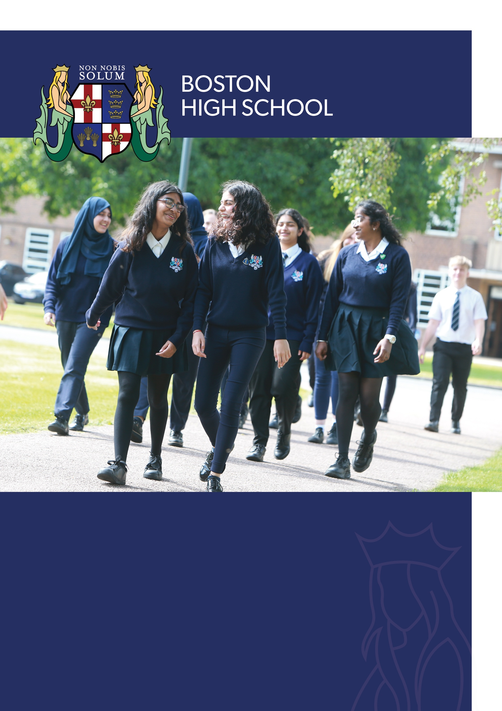
APPLICANT INFORMATION PACK

COVER SUPERVISOR
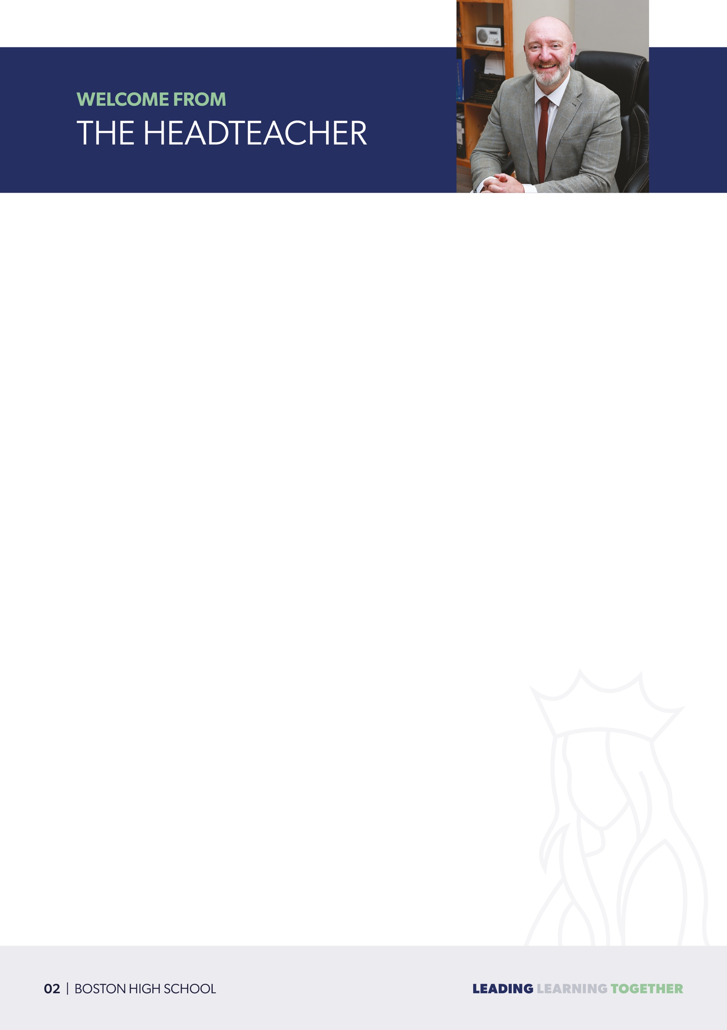
Dear Applicant,

Firstly, thank you for your interest in the position of Cover Supervisor at Boston High School.

This role is... an exciting opportunity for you to join our highly effective school.

At Boston High School our mission statement is LEADING, LEARNING, TOGETHER:

- Leading, as individuals, by example and as a community
- Achieving our Learning ambitions and potential
- Most importantly, supporting one another Together at school and beyond.

Founded in January 1921, Boston High School has a proud legacy of excellence, relocating to our current location on Spilsby Road in 1938. As a highly sought-after and oversubscribed Selective Academy for girls aged 11-16, and home to a vibrant mixed comprehensive Sixth Form for students aged 16-19, we are dedicated to fostering a dynamic and inclusive learning environment.

If you would like to discuss details of this post further or arrange a visit to our school, please email
jobs@bostonhighschool.co.uk

For further information regarding Boston High School can be found at: www.bostonhighschool.co.uk

Should you decide to apply for this post, I look forward to receiving your application and I wish you well with the process.

Kindest regards,

Mr A Fulbrook
Headteacher

The school has developed an ambitious and inclusive curriculum for all pupils. It offers a broad range of academic subjects that meet the interests and aspirations of pupils…

The school promotes pupils’ personal development well. A well-thought-out enrichment course is complemented by a range of extra-curricular activities and visits.

Staff feel well cared for and are highly supportive of the school… Morale is positive.
We are dedicated to supporting our staff through our Wellbeing and Workload Charter, along with significant investment in continuous professional development (CPD) at every stage of their career. Our robust Professional Pathways structure offers tailored support, including comprehensive guidance for Early Career Teachers (ECTs), National Professional Qualifications (NPQs), and preparation for future leadership roles. This commitment ensures that every team member is empowered to grow, succeed, and embrace their next professional challenge with confidence.

Our most recent Ofsted inspection in July 2024 resulted in a GOOD rating, affirming the strength of our school community and our commitment to excellence.

To see our school’s Ofsted reports please click here.

We are proud to share some of the standout highlights from this glowing report, which showcases the dedication, passion, and high standards and expectations that define Boston High School:
At the heart of our school lies a commitment to core values, embodied in our CODE, which emphasises aspiration, fairness, equality, the rule of law, respect, tolerance, justice, care, and courtesy.

These principles guide everything we do, helping our students thrive both academically and personally.

Commitment | Opportunity | Discipline | Excellence:

COMMITMENT; towards our school, ambitions, achievement, progress, development, learning, safety. Also, commitment to each other, to our duties, and our broader commitment to local, national and global needs.

OPPORTUNITY; a determination to take advantage of opportunities in life; to be the best we can be.

DISCIPLINE; a recognition that a disciplined and focused attitude is essential in order to achieve our best and to give of our best.

EXCELLENCE; a determination to achieve to our highest possible standards and contribute fully to society.

The school has an inclusive and welcoming ethos… Pupils say that they feel safe in this popular school.

Pupils behave and attend well. They are friendly and polite.

Pupils with special educational needs and/or disabilities (SEND) are well supported. They benefit from the close support of adults and dedicated learning spaces, such as the ‘hub’ and ‘snug’, which strongly promote inclusion in the main school and into the sixth form.
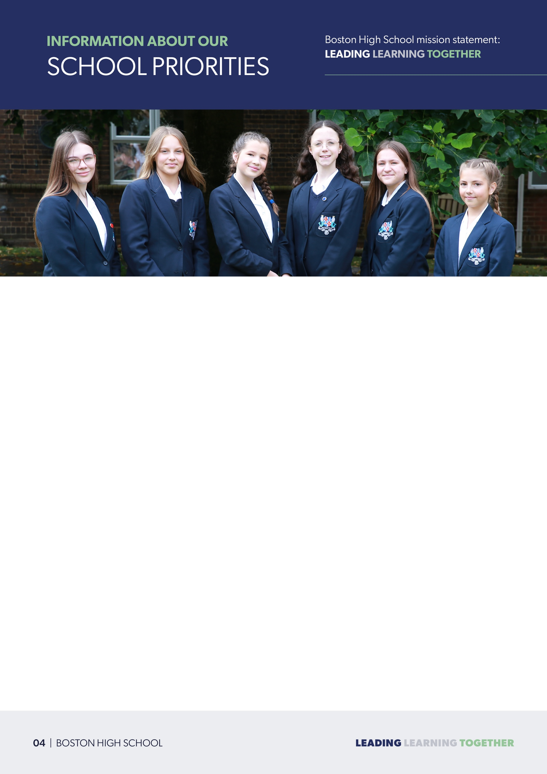
We believe in our students and in their generation; we pledge to do all that we can to help them to achieve high standards / outcomes and live fulfilled, safe, happy, and productive lives in their communities as valued citizens.

We will recognise and prioritise the safety, well-being and development of our whole community and ensure students and staff are cared for, supported, and are kept safe – physically and emotionally.

Leaders will continue to ensure that we maintain a clear and ambitious vision for providing high-quality education to all pupils and that is seen through strong, shared values, policies actions and outcomes.

Our culture of safeguarding is paramount to all at BHS. Our culture, policy and practice must identify those at risk or who need help; we must help reduce the risks through support, referral in a timely manner and manage safe recruitment, training, awareness, and any allegations to avoid risk and Keep Children Safe in Education.

- We seek to continually develop as teachers and as a school; reviewing and developing delivery, teaching methodologies and pedagogy to ensure our curriculum delivery meets needs.
- We seek to ensure that all learners can excel, succeed, and achieve beyond potential and fulfil their ambitions.

- Our whole community culture should be based upon the principles of aspiration, excellence, fairness, respect, tolerance, justice, care, courtesy, compassion; underpinned by ensuring we maintain our non-negotiable professional standards built upon integrity and trust.
- Standards of behaviour and discipline are high; we are firm but fair in application. Maintaining a positive learning environment.
- Our learners are individuals, and we respect their needs. Furthermore, we expect all to respect the needs of others.
- We are ambitious for our learners; we expect all to work hard, to accept the challenge, to delight in the accumulation of knowledge and to find enrichment, reward, and enjoyment in their learning.
- We are determined to build upon the principles of reflective practice, evaluation, and quality assurance to strive to be an improving Teaching & Learning community; school information informs practice; improves outcomes.
- We aspire for our learners to develop the capacity to become highly capable, independent, caring, considerate and responsible people to make a positive contribution to our society and our environment in the service of others.
- We aspire for our learners to be adaptable, resilient, and confident people who embrace, and grasp opportunities presented by change; to make a positive impact.

Behaviour & Personal Development mission statement: Commitment, Opportunity, Discipline, Excellence

COMMITMENT: Every student is committed.
- Exhibits a thirst for learning and knowledge, demonstrating perseverance.
- Takes responsibility for own learning and behaviour, committed to our school values.
- Has high expectations for self in all areas of school including classwork, homework, attendance, and wears our school uniform correctly, taking pride in appearance.
- Always acts safely, looking after self and others.

OPPORTUNITY: Every student grasps opportunities.
- Attends school, arrives on time, and is prepared for the day ahead, ready to learn.
- Takes advantage of opportunities that are presented and actively seeks opportunities.
- Is working towards a personal goal and aspirations.
- Embraces the chance to learn from others.

DISCIPLINE: Every student considers themselves and others.
- Takes ownership of own behaviour and understands the consequences.
- Treats others the way they want to be treated.
- Accepting of other’s views and beliefs, considering our British Values.
- Respects the school community and school environment, demonstrating respect for our school values, standards, and expectations.

EXCELLENCE: Every student is ambitious.
- Embraces change and challenge.
- Actively learns from mistakes.
- Applies a positive mindset.
- Is adaptable; looks to solve problems and thinks creatively.

Staff: Curriculum mission statement: Love of Learning, Opportunity, Resilience, Respect

Our Curriculum Intent, Implementation and Impact are rooted in the desire to instil a Love of Learning, create lifelong Opportunities, instil a sense of Respect, and develop our learners’ Resilience; we define this as our LLORR curriculum mission statement:

- We seek to continually develop as teachers and as a school; reviewing and developing delivery, teaching methodologies and pedagogy to ensure our curriculum delivery meets needs – we are a learning community for all (inc. staff CPD).
- We seek to ensure that all learners can excel, succeed, and achieve beyond potential and fulfil their ambitions.
- Our whole curriculum culture is built upon the principles of aspiration, excellence and fairness.
- Our learners are individuals, and we respect their needs. Furthermore, we expect all to respect the needs of others in our learning community.
- We are ambitious for our learners; we expect all to work hard, to accept the challenge, to delight in the accumulation of knowledge and to find enrichment, reward, and enjoyment in their learning.
- We are determined to build upon the principles of reflective practice, evaluation, and quality assurance to strive to be an improving Teaching & Learning community.
- We aspire for our learners to be adaptable, resilient, and confident people who embrace, and grasp opportunities presented by change; to make a positive impact at Boston High School and beyond.
- We do all that we can to ensure curriculum choices are made to best serve our students and prepare them for the next steps on their educational / lifelong learning journey.

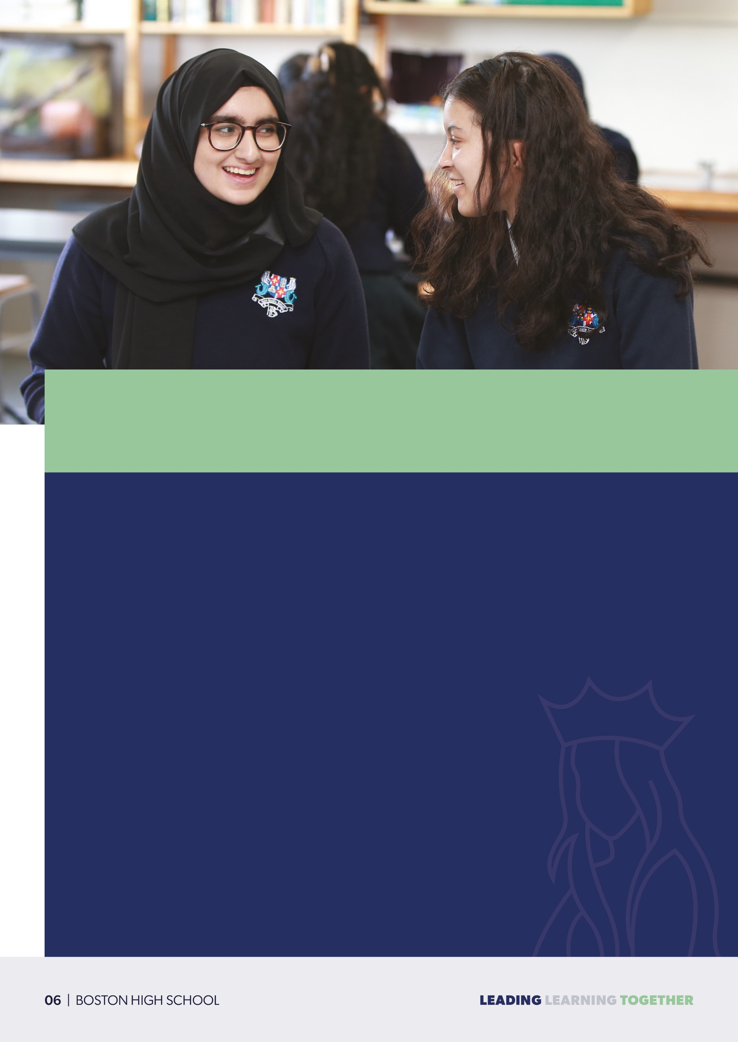

IMPORTANT INFORMATION

As a key member of our school, you will support the delivery of cover lessons to our highly able, motivated students. You will work alongside a collaborative, supportive team of educators committed to providing exceptional learning experiences.

This is a fantastic chance to become part of a department that truly values its staff and fosters an environment of success. If you're an enthusiastic and dynamic individual, able to inspire and challenge highly able students and have a desire to work in a supportive and forward-thinking school, looking for a fresh, exciting opportunity, we would love to hear from you.
SALARY | £18,546 - £19,449
JOB DETAILS | 32.5 hours per week
REQUIRED FOR | September 2025
APPLICATIONS CLOSE | 30th April 2025
INTERVIEW DATE | 6th May 2025

COVER SUPERVISOR

Job Title: Cover Supervisor
Reports to: Deputy Head Curriculum

Purpose of job:
- To supervise pupils and their work when teacher is absent.
- Where there are no cover requirements in a day - to work as a TA in an assigned subject area.
- The role involves taking sole charge of a group of pupils. There will be a system of supervision in place from qualified teachers in case of any difficulties.

Main Responsibilities:
- Supervise work that has been set in accordance with the school policy
- Manage the behaviour of pupils whilst they are undertaking the work, to ensure a constructive learning environment is held.
- Respond to any questions from pupils about process and procedures.
- Deal with any immediate problems or emergencies according to the school’s policies and procedures.
- Collect any completed work after the lesson, complete the lesson feedback form for the absent staff, and return it to the appropriate teacher.
- Report back as appropriate using the school’s CODE procedures on the behaviour of pupils during class, and any issues arising during the lesson.
- Carry out supervision of pupils in the Student Support Centre, if not being utilised for cover, as directed by the Line Manager.
- To act as Form Tutor, fulfilling all of the relevant admin tasks.

Management of staff:
- There will be no requirements to manage or supervise other staff.
Contacts and Relationships within school:
- The role will require communication with staff within the school.

Work Environment:
- The role will involve working with highly able students in regular classes across the key stages.

Available Resources:
- Standard learning resources are available, and computing and ICT resources are available within school.

Knowledge and Skills (to be fully successful in post):
The role requires the following base skills:
- A willingness to learn.
- Good communication both written and oral.
- The ability to understand the needs of children and young people.

Other duties:
- Additional duties that are appropriate to the role may be asked upon by the Deputy Head.

JOB DESCRIPTION

COVER SUPERVISOR

QUALIFICATIONS | ESSENTIAL | DESIRABLE
Qualified teacher status |  | 
EXPERIENCE AND PROFESSIONAL ATTRIBUTES | ESSENTIAL | DESIRABLE
Exemplary classroom practitioner
Experience of planning and teaching secondary school curriculum
Excellent communication and interpersonal skills
Ability to demonstrate a high level of subject and curriculum knowledge
Motivates staff and student, and sets an example of high standards
Evidence of continued professional development
SKILLS AND BEHAVIOURS | ESSENTIAL | DESIRABLE
Works well in a team
Selects appropriate teaching material and makes good use of available resources
Confident user of IT
Ensures a safe learning environment
Secures high standards of behaviour in the classroom
Takes an active approach to self-development
MANAGEMENT AND LEADERSHIP | ESSENTIAL | DESIRABLE
Ability to make informed use of assessment, information and data to raise achievement
SAFEGUARDING | ESSENTIAL | DESIRABLE
Is pro-active in reporting safeguarding issues and concerns to relevant persons, in accordance to school policy
Promotes welfare of students

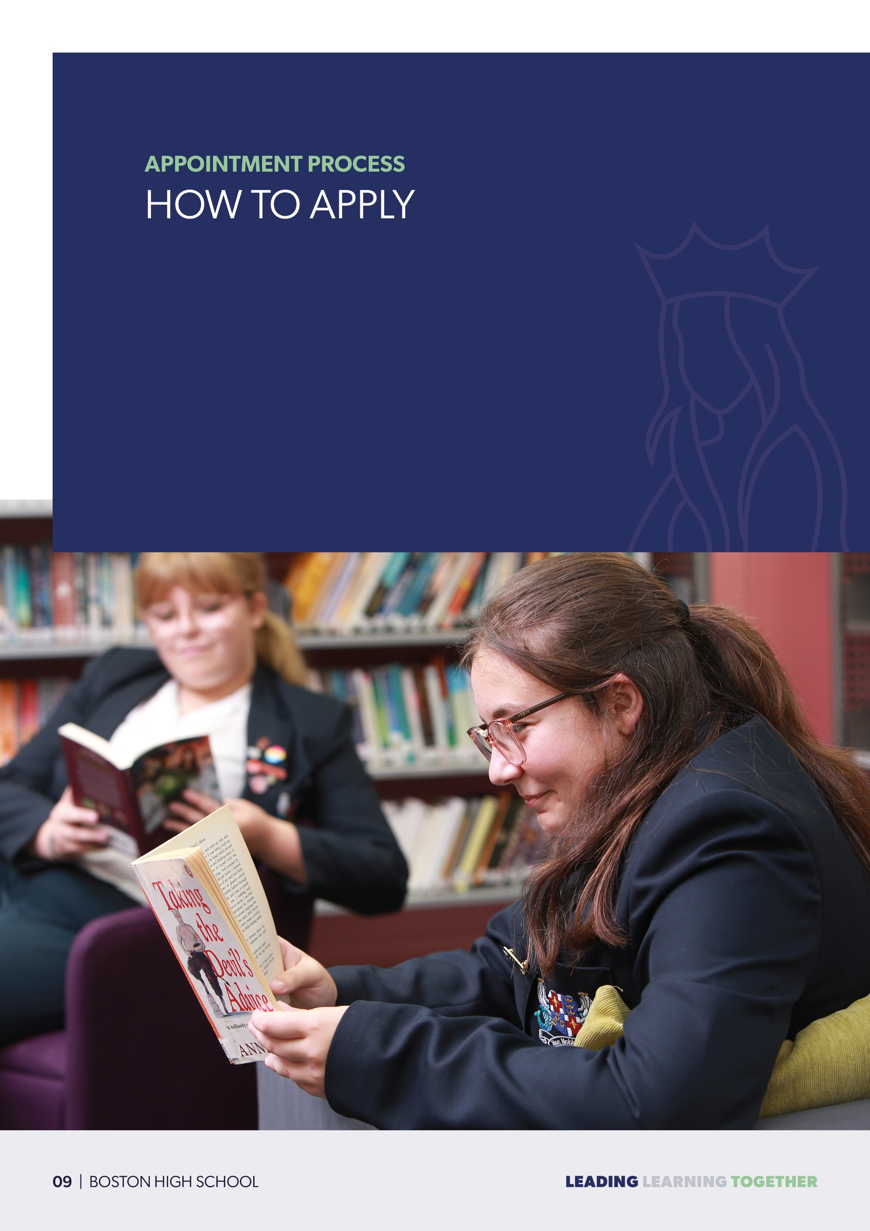
Application Forms can be found on our school website www.bostonhighschool.co.uk.

Completed forms can be submitted to jobs@bostonhighschool.co.uk.

This school is committed to safeguarding and promoting the welfare of children, consequently an enhanced Disclosure and Barring Service Check (DBS) will be required. All pre-employment undertaken out are in line with “Keeping Children Safe in Education”.

